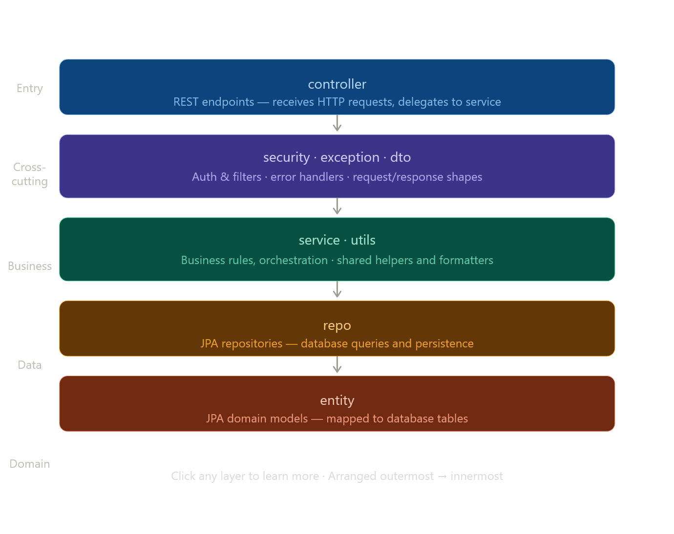
- Controller Package
- AuthController.java

@RestController
shorthand for @Controller + @ResponseBody.
@Controller tells Spring: "this class handles incoming HTTP requests" — register it as a web component.
@ResponseBody tells Spring: "whatever these methods return, serialize it directly into the HTTP response body as JSON" — don't look for a view/template file.
So without @RestController, returning a ResponseEntity<Response> would confuse Spring into thinking you want to render an HTML page.
@RequestMapping("/auth")
Sets the base path for all endpoints in this class. Every method-level mapping gets this prefix prepended. So @PostMapping("/register") becomes /auth/register, and @PostMapping("/login") becomes /auth/login.
@Autowired
private IUserService userService;
Without Spring, you'd have to do this manually:
private IUserService userService = new UserService();
You're instantiating the concrete class yourself and holding it in a variable typed to the interface. That's the "primitive" way — you're in charge of creating and managing that object.
The problem with doing it manually is:
- What if UserService itself needs other objects to work? You'd have to create those too, and pass them in. Then those objects might need other objects. You end up with a chain like:
UserRepository repo = new UserRepository(dataSource);
JwtUtils jwt = new JwtUtils();
PasswordEncoder encoder = new BCryptPasswordEncoder();
IUserService userService = new UserServiceImpl(repo, jwt, encoder);
Every time you need a controller, you rebuild that whole chain by hand. And if one dependency changes, you update it everywhere.

What @Autowired does
Spring maintains a container — essentially a big map of all the objects (called beans) it has created from your classes. When your app starts up, Spring:
- Scans your project
- Finds every class annotated with @Service, @Repository, @Component, etc.
- Creates one instance of each and stores it
- When it sees @Autowired, it looks up the right bean and injects it for you
So you never write new for your services, repositories, or utilities. Spring handles the whole chain automatically.
The formal name for this pattern is Dependency Injection, and the Spring container that manages it is called the IoC container (Inversion of Control — because Spring controls object creation, not you).
@RestController, @Service, etc are very intentional keywords in spring?
They are not just labels — they are instructions to Spring.
When Spring boots up, it does a component scan — it walks through all your packages looking for specific annotations. Each annotation tells Spring something different about what to do with that class:
Annotation | What Spring does with it
@RestController | Create a bean, register it as an HTTP request handler
@Service | Create a bean, mark it as business logic layer
@Repository | Create a bean, mark it as data access layer, adds DB exception translation
@Component | Create a bean, generic — doesn't fit the others
They are all technically the same under the hood
All four tell Spring "create one instance of this class and manage it." The difference is semantic — they communicate the role of the class to both Spring and other developers reading the code.
@Service and @Repository are literally built on top of @Component.
The key point
Without these annotations, Spring doesn't know those classes exist. It won't create instances of them, won't inject them anywhere, and @Autowired will fail at startup because there's nothing to inject.
The annotation is what puts the class on Spring's radar.

The register endpoint: @PostMapping("/register")
@PostMapping("/register")
public ResponseEntity<Response> register(@RequestBody User user) {
Response response = userService.register(user);
return ResponseEntity.status(response.getStatusCode()).body(response);
}
@PostMapping("/register") — this method handles POST /auth/register only. POST because you're creating something (a new user).
@RequestBody User user — Spring reads the raw JSON from the request body and deserializes it into a User object automatically (via Jackson). So a client sends { "name": "Jay", "email": "...", "password": "..." } and Spring hands you a populated User instance.
ResponseEntity.status(response.getStatusCode()).body(response) — instead of returning a plain object, you're wrapping it in a ResponseEntity. This lets you control the HTTP status code dynamically. The status code comes from inside the Response object itself — meaning the service layer decides what code to send back (200, 400, 409, etc.), and the controller just forwards it.
Here's the full summary:
@PostMapping("/register")
An HTTP request comes in with method = POST and path = /auth/register, Spring calls the register method on the AuthController class.

The method signature
public ResponseEntity<Response> register(@RequestBody User user)
This is a normal Java method. It takes a User object as a parameter and returns a ResponseEntity<Response>. Spring sees @RequestBody and tells Jackson to read the incoming JSON and build the User object automatically before the method even runs

Line 1

Response response = userService.register(user);
Hand the User object to the service layer. The service does all the real work — validation, password hashing, saving to the database. It creates and returns a Response object containing a status code and a message. The controller just catches it.

Line 2
return ResponseEntity.status(response.getStatusCode()).body(response);
Build an HTTP response using the builder pattern. Set the status code to whatever number the service put inside the Response object. Set the body to the Response object itself. Return it to Spring, which hands it to Jackson, which calls all the getters on Response and converts it to JSON to send back to the client.

The full flow in one picture
Client sends JSON
│
▼
Jackson builds User object (@RequestBody)
│
▼
Service does all the work (userService.register)
│
▼
Service returns Response object (statusCode + message)
│
▼
Controller wraps it (ResponseEntity.status().body())
│
▼
Jackson converts Response to JSON
│
▼
Client receives HTTP status + JSON body

One sentence
The method receives a User from the client, gives it to the service, gets a Response back, wraps it in a ResponseEntity so the HTTP status code is set correctly, and returns it — Jackson handles all the JSON conversion automatically.

- UserController.java

@PreAuthorize("hasAuthority('ADMIN')")
@PreAuthorize("hasAuthority('ADMIN')")

This is a **security gate** on the method. Before Spring even runs `getAllUsers()`, it checks the identity of whoever is making the request and asks: *"does this person have the ADMIN authority?"*

If yes — the method runs normally.

If no — Spring blocks it immediately and returns a `403 Forbidden` response. Your method never even gets called.

Think of it as a security guard standing in front of the method:

Request arrives
│
▼
@PreAuthorize checks: is this user an ADMIN?
│
YES│ NO│
▼ ▼
method runs 403 Forbidden
method never runs
You'll see how the ADMIN authority gets assigned to a user when you get to the security layer.
no @RequestBody parameter

public ResponseEntity<Response> getAllUsers()
Empty parameter list. Because this is a GET request — the client is just asking for all users, they're not sending any data. Nothing to deserialize, nothing to map. Spring just calls the method directly.

@PathVariable
Look at the URL:
@DeleteMapping("/delete/{userId}")
The {userId} in curly braces is a path variable — a dynamic slot in the URL. It means the actual user ID will be part of the URL itself when the client makes the request:
DELETE /users/delete/42
DELETE /users/delete/105
DELETE /users/delete/7
The number at the end changes every time depending on which user you want to delete.
Now look at the parameter:
@PathVariable("userId") String userId
@PathVariable("userId") tells Spring: "extract whatever value is sitting in the {userId} slot of the URL and inject it into this parameter."
So for DELETE /users/delete/42, Spring reads 42 out of the URL and gives it to your method as userId = "42".
a DELETE request doesn't need a JSON body. The only thing you need to tell the server is the ID of what to delete, and that fits naturally in the URL.

One sentence
@PathVariable extracts a dynamic value embedded directly in the URL and injects it into your method parameter — no request body needed.

SecurityContextHolder

@GetMapping("/get-logged-in-profile-info")
public ResponseEntity<Response> getLoggedInUserProfile() {
Authentication authentication = SecurityContextHolder.getContext().getAuthentication();
String email = authentication.getName();
Response response = userService.getMyInfo(email);
return ResponseEntity.status(response.getStatusCode()).body(response);
}
Remember from @PreAuthorize — when a request comes in, Spring Security decodes the JWT token and stores the current user's information in something called the SecurityContext.
SecurityContextHolder is simply the class that holds that SecurityContext. Think of it as a box that exists for the duration of the request:
SecurityContextHolder.getContext().getAuthentication();
```

Read it left to right:
```
SecurityContextHolder → the holder/box
.getContext() → get the SecurityContext inside it
.getAuthentication() → get the Authentication object inside that
The Authentication object contains everything Spring Security knows about the current user — their email, their authorities, whether they're authenticated.

authentication.getName()
String email = authentication.getName();
.getName() returns the principal — the unique identifier Spring Security used to identify this user. In most Spring Security setups with JWT, this is the email address because that's what gets embedded in the token when the user logs in.
So this line is simply saying: "give me the email of whoever is currently making this request."

One sentence
Instead of trusting the client to tell you who they are via a URL parameter, you read their identity directly from the SecurityContext — which was populated from their JWT token by Spring Security — making it impossible to spoof.
Other alternatives
@GetMapping("/get-logged-in-profile-info")
public ResponseEntity<Response> getLoggedInUserProfile(@AuthenticationPrincipal UserDetails userDetails) {
String email = userDetails.getUsername();
Response response = userService.getMyInfo(email);
return ResponseEntity.status(response.getStatusCode()).body(response);
}
_______________________________________________________________
@GetMapping("/get-logged-in-profile-info")

public ResponseEntity<Response> getLoggedInUserProfile(Principal principal) {

String email = principal.getName();

Response response = userService.getMyInfo(email);

return ResponseEntity.status(response.getStatusCode()).body(response);

}

@GetMapping("/get-user-bookings/{userId}")
public ResponseEntity<Response> getUserBookingHistory(@PathVariable("userId") String userId) {
Response response = userService.getUserBookingHistory(userId);
return ResponseEntity.status(response.getStatusCode()).body(response);
}
Nothing new here at all. You know everything in this method.

Quick read through
@GetMapping("/get-user-bookings/{userId}")
GET request. {userId} is a dynamic slot in the URL.
public ResponseEntity<Response> getUserBookingHistory(@PathVariable("userId") String userId)
@PathVariable extracts the ID from the URL and injects it into userId.
Response response = userService.getUserBookingHistory(userId);
return ResponseEntity.status(response.getStatusCode()).body(response);
Same pattern. Hand the ID to the service, get a Response back, wrap it, return it.

Only thing worth noting
No @PreAuthorize — so any authenticated user can access this. Though in a real production app you might want to add a check here to make sure users can only see their own booking history, not someone else's. Either via @PreAuthorize or the same SecurityContextHolder approach you just saw.
- RoomController.java
@PostMapping("/add")
@PreAuthorize("hasAuthority('ADMIN')")
public ResponseEntity<Response> addNewRoom(
@RequestParam(value = "photo", required = false) MultipartFile photo,
@RequestParam(value = "roomType", required = false) String roomType,
@RequestParam(value = "roomPrice", required = false) BigDecimal roomPrice,
@RequestParam(value = "roomDescription", required = false) String roomDescription
) {
if (photo == null || photo.isEmpty() || roomType == null || roomType.isBlank() || roomPrice == null || roomType.isBlank()) {
Response response = new Response();
response.setStatusCode(400);
response.setMessage("Please provide values for all fields(photo, roomType,roomPrice)");
return ResponseEntity.status(response.getStatusCode()).body(response);
}
Response response = roomService.addNewRoom(photo, roomType, roomPrice, roomDescription);
return ResponseEntity.status(response.getStatusCode()).body(response);
}
Several new things here. Let's go one by one.

What you already know
@PostMapping("/add")
@PreAuthorize("hasAuthority('ADMIN')")
public ResponseEntity<Response> addNewRoom(...)
return ResponseEntity.status(response.getStatusCode()).body(response);
All familiar. POST request, admin only, same return pattern.

New thing 1 — @RequestParam
@RequestParam(value = "roomType", required = false) String roomType
You've seen @RequestBody — reads the whole JSON body and maps it to one object.
@RequestParam is different. It reads individual fields sent in the request. These fields come in as form data — not JSON. Think of it like an HTML form where each field is sent separately:
photo=<file>
roomType=Deluxe
roomPrice=150.00
roomDescription=A nice room
Each @RequestParam picks out one field by name and injects it into its parameter.

New thing 2 — required = false
@RequestParam(value = "photo", required = false)
By default @RequestParam is required — if the client doesn't send it, Spring throws an error immediately before your method even runs.
required = false tells Spring: "this field is optional — if it's missing, just inject null instead of throwing an error."
That's why the developer then manually checks for nulls right after:
if (photo == null || photo.isEmpty() || roomType == null ...)
They turned off Spring's automatic validation and decided to handle it themselves.

New thing 3 — MultipartFile
@RequestParam(value = "photo", required = false) MultipartFile photo
MultipartFile is a Spring type specifically for file uploads. When a client sends a file — an image, a PDF, anything — Spring wraps it in a MultipartFile object which gives you methods like:
photo.isEmpty() // is the file empty?
photo.getBytes() // get the raw file bytes
photo.getOriginalFilename() // get the file name
photo.getContentType() // get the file type e.g. "image/jpeg"
So MultipartFile is just Spring's way of representing an uploaded file in Java.

New thing 4 — BigDecimal
@RequestParam(value = "roomPrice", required = false) BigDecimal roomPrice
BigDecimal is a Java type for precise decimal numbers. You might wonder — why not just use double or float?
Because double and float have floating point precision issues in Java:
double price = 0.1 + 0.2;
System.out.println(price); // prints 0.30000000000000004
For money you can never afford rounding errors. BigDecimal stores numbers with exact precision:
BigDecimal price = new BigDecimal("0.1").add(new BigDecimal("0.2"));
System.out.println(price); // prints 0.3
Any time you deal with money in Java, always use BigDecimal.

New thing 5 — manual validation block
if (photo == null || photo.isEmpty() || roomType == null || roomType.isBlank() || roomPrice == null || roomType.isBlank()) {
Response response = new Response();
response.setStatusCode(400);
response.setMessage("Please provide values for all fields(photo, roomType,roomPrice)");
return ResponseEntity.status(response.getStatusCode()).body(response);
}
Two things to notice here:
First — this is the first time you see new Response() in a controller. The developer is manually building a Response object instead of getting one from the service. This is an early exit — if validation fails, there's no point calling the service at all. Return a 400 Bad Request immediately.
Second — notice there are two return statements in this method now:
// return 1 - early exit if validation fails
if (photo == null || ...) {
return ResponseEntity.status(400).body(response);
}

// return 2 - normal flow if validation passes
Response response = roomService.addNewRoom(...);
return ResponseEntity.status(response.getStatusCode()).body(response);
Java exits the method the moment it hits a return. So if validation fails, it returns immediately and the service call below never happens.

The full flow
Request arrives with form data
│
▼
@RequestParam extracts each field individually
│
▼
Manual validation check
│
FAILS │ PASSES│
▼ ▼
return 400 immediately roomService.addNewRoom()
method stops │
▼
return service Response

One sentence summary
This method receives form data instead of JSON, handles a file upload via MultipartFile, uses BigDecimal for precise money values, and manually validates the inputs before even touching the service layer.

@GetMapping("/available-rooms-by-date-and-type")
public ResponseEntity<Response> getAvailableRoomsByDateAndType(
@RequestParam(required = false) @DateTimeFormat(iso = DateTimeFormat.ISO.DATE) LocalDate checkInDate,
@RequestParam(required = false) @DateTimeFormat(iso = DateTimeFormat.ISO.DATE) LocalDate checkOutDate,
@RequestParam(required = false) String roomType
) {
if (checkInDate == null || roomType == null || roomType.isBlank() || checkOutDate == null) {
Response response = new Response();
response.setStatusCode(400);
response.setMessage("Please provide values for all fields(checkInDate, roomType,checkOutDate)");
return ResponseEntity.status(response.getStatusCode()).body(response);
}
Response response = roomService.getAvailableRoomsByDataAndType(checkInDate, checkOutDate, roomType);
return ResponseEntity.status(response.getStatusCode()).body(response);
}
Only two new things here. Everything else you already know.

What you already know
@GetMapping("/available-rooms-by-date-and-type")
GET request. Fetching data.
@RequestParam(required = false) String roomType
Optional form field. Already covered.
if (checkInDate == null || roomType == null ...)
Manual validation block. Early exit with 400. Already covered.
Response response = roomService.getAvailableRoomsByDataAndType(...);
return ResponseEntity.status(response.getStatusCode()).body(response);
Same pattern every time.

New thing 1 — LocalDate
LocalDate checkInDate
LocalDate is a Java type that represents a date with no time — just year, month, day. Java has several date types:
LocalDate → date only e.g. 2024-12-25
LocalTime → time only e.g. 14:30:00
LocalDateTime → date and time e.g. 2024-12-25T14:30:00
For hotel check-in and check-out, you only care about the date — not what hour the booking starts. So LocalDate is the right choice here.

New thing 2 — @DateTimeFormat
@DateTimeFormat(iso = DateTimeFormat.ISO.DATE) LocalDate checkInDate
The client sends the date as a String in the URL:
/available-rooms-by-date-and-type?checkInDate=2024-12-25&checkOutDate=2024-12-30&roomType=Deluxe
But your parameter is a LocalDate, not a String. Spring needs to know how to convert that String into a LocalDate object.
@DateTimeFormat(iso = DateTimeFormat.ISO.DATE) tells Spring: "expect the date in ISO format — yyyy-MM-dd — and convert it to a LocalDate automatically."
Without this annotation Spring wouldn't know what date format to expect and would throw an error trying to convert the String.

The two annotations working together
@RequestParam(required = false)
@DateTimeFormat(iso = DateTimeFormat.ISO.DATE)
LocalDate checkInDate
Read them separately:
@RequestParam → get this value from the request parameters
@DateTimeFormat(...) → and when converting it, expect this date format
LocalDate checkInDate → inject it as a LocalDate object
Two annotations on the same parameter, each doing a different job.

One sentence
LocalDate represents a date without time, and @DateTimeFormat tells Spring how to convert the incoming date String into that LocalDate object automatically.

- DTO Package

- UserDTO.java
@Data
@JsonInclude(JsonInclude.Include.NON_NULL)
public class UserDTO {
private Long id;
private String email;
private String name;
private String phoneNumber;
private String role;
private List<BookingDTO> bookings = new ArrayList<>();
}
Two new things here. Everything else is familiar.

What you already know
private Long id;
private String email;
private String name;
private String phoneNumber;
private String role;
private List<BookingDTO> bookings = new ArrayList<>();
Plain Java class with fields. List<BookingDTO> is a list of objects inside an object — you already know Jackson handles that recursively.

New thing 1 — @Data
@Data
This is a Lombok annotation. You've actually dealt with Lombok before — remember when you removed it from your Student project and had to write everything manually?
@Data automatically generates at compile time:
getters → for all fields
setters → for all fields
toString() → string representation of the object
equals() → compare two objects
hashCode() → hash the object
So instead of writing:
public Long getId() { return id; }
public void setId(Long id) { this.id = id; }
public String getEmail() { return email; }
public void setEmail(String email) { this.email = email; }
// ... for every single field
You just write @Data and Lombok generates all of that for you at compile time. Jackson can then call those getters when converting to JSON.

New thing 2 — @JsonInclude(JsonInclude.Include.NON_NULL)
@JsonInclude(JsonInclude.Include.NON_NULL)
Remember how Jackson calls all getters and maps them to JSON? By default it includes every field — even null ones:
{
"id": 1,
"email": "jay@email.com",
"name": "Jay",
"phoneNumber": null,
"role": null,
"bookings": []
}
NON_NULL tells Jackson: "skip any field whose value is null — don't include it in the JSON output at all."
So if phoneNumber and role are null, the JSON becomes:
{
"id": 1,
"email": "jay@email.com",
"name": "Jay",
"bookings": []
}
Cleaner response. The client only receives fields that actually have values.

Why a DTO instead of the User entity directly
You already noticed this in AuthController — the /register endpoint accepts a raw User entity which is not ideal. UserDTO exists to solve that. It exposes only the fields you want the client to see — notice there is no password field here. Even if the User entity has a password field, it will never leak to the client because UserDTO simply doesn't have it.

private List<BookingDTO> bookings = new ArrayList<>();
This represents the relationship between a user and their bookings. A user can have many bookings — so instead of just returning the user's basic info, this DTO can also carry the full list of that user's bookings nested inside:
{
"id": 1,
"email": "jay@email.com",
"name": "Jay",
"bookings": [
{ "id": 101, "checkInDate": "2024-12-25", "roomType": "Deluxe" },
{ "id": 102, "checkInDate": "2025-01-10", "roomType": "Standard" }
]
}
One response gives the client everything — the user and all their bookings in one shot. You saw this pattern earlier when we talked about Jackson handling nested objects recursively.

Why = new ArrayList<>() ?
This is defensive initialization. It means the list is never null — it starts as an empty list by default.
Without it:
private List<BookingDTO> bookings; // defaults to null
If a user has no bookings and you try to do anything with that list:
userDTO.getBookings().size() // NullPointerException - bookings is null
Your app crashes.
With it:
private List<BookingDTO> bookings = new ArrayList<>(); // defaults to empty list
Same situation but now:
userDTO.getBookings().size() // returns 0 - no crash
And in the JSON output, instead of:
{ "bookings": null }
You get:
{ "bookings": [] }
Which is much cleaner and easier for the frontend to handle — it can just loop over an empty array instead of checking for null first.

One sentence
@Data lets Lombok generate all boilerplate getters and setters automatically, and @JsonInclude(NON_NULL) tells Jackson to skip null fields when converting to JSON — keeping the response clean. List<BookingDTO> carries the user's bookings nested inside the response, and = new ArrayList<>() ensures it's never null — just empty — when a user has no bookings yet.

